Brandon Bankston

S&B Landscaping Website

SPMP

Professor Broadwater

31 March 2021

1. **Introduction**
   1. Project Description/Overview

* This landscaping business website will consist of multiple sections throughout the landing page to associate what we would provide as a business. From the home page, there will be subpages that include gallery, testimonials, and landscaping services. This will give us a better way to show what we provide to future clients. There will also be a contact us page, so we can allow clients to reach out to set up appointments with us through the website for easier organization and less room for miscommunication.
  1. Product Deliverables
* This landscaping business site will be delivered to current and future clients as early as April 2021, for the upcoming summer season.
* Clients can expect a functional site by May 2021.
  1. Evolution of SPMP

The evolution of this SPMP would be the gallery would change because as we progress and do jobs, pictures will update. Testimonials would come in as new clients give us reviews. So, those two features would be the only plans for change on the website.

1. **Managerial Process** 
   1. Management Objectives and Priorities

* Philosophy of this process is each step should be thoroughly looked at for bugs and errors to avoid a faulty website.
* No money will be spent, aside from purchasing the domain name and hosting.

Requirements have been uploaded to GitHub.

Schedule is put into a Gantt Chart and the bottom of this word doc.

* 1. Assumptions, Dependencies and Constraints
* Dependent on if plugins are free or not.
* Also, if certain features are made available to WordPress in general.
  1. Risk Management
* Size of project

Focus on main features of website if deadline approaches faster than expected. To not worry about extra specific details and to establish main functionality first.

* Risk of plugins

Certain plugins are not available to basic user account would be a risk. A lot of plug ins are expensive.

1. **Technical Process**

Methods and Tools

* Methods used:

Process and send emails to desired emails.

Contact page would save and upload info to email.

* Tools used would be:

WordPress

Github

Namecheap

1. **Work Packages**
   1. WBS Chart

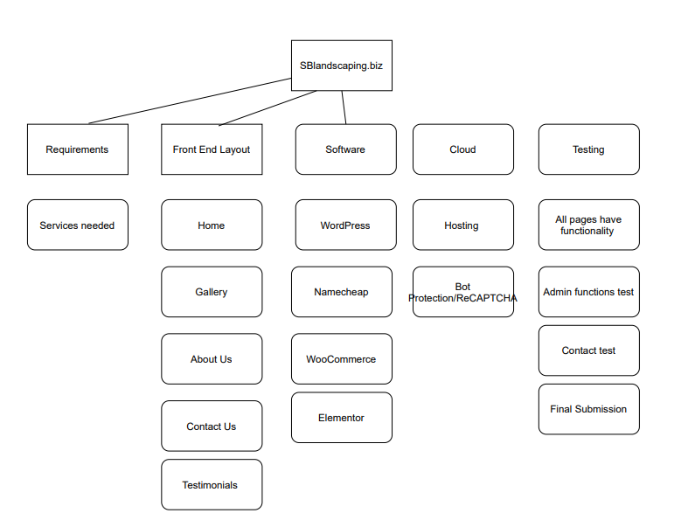

* 1. Gantt Chart

